
Shocks, Shutdowns & Shrinking IPOs:
September 2025 Market Commentary

Washington Shutdown: More Than Just Political Theatre
The White House is pitching the current government shutdown as an “unprecedented opportunity” to rein in costs, with the Office of Management and Budget already drawing up a list of possible cuts. On the surface, that sounds like fiscal discipline. But the reality is that shutdowns usually come with plenty of short-term pain — from furloughed federal workers and delayed services to the knock-on effect on contractors and local economies. If the standoff drags on, growth could take a hit and the uncertainty alone tends to spook businesses into delaying investment decisions.
Markets have learned to treat shutdown headlines as “noise”, but genuine reductions in federal spending would be different. They could soften demand and nudge inflation lower, which often translates into a steeper yield curve as investors price in slower growth ahead. That’s not exactly good news for risk appetite in the short run.
Still, there’s a silver lining: if handled with a steady hand, trimming back unnecessary programmes could help streamline government finances and reduce long-term pressure on inflation. In other words, a painful process now might set the stage for a leaner, more efficient backdrop later — not glamorous, but potentially healthier in the long run.

Corporate Earnings: Bright Spots, But No Clear Consensus
Within BlackRock’s latest Fundamental Equities Earnings Review shows that while headline numbers often look solid, the story underneath is far less uniform. U.S. companies are still delivering positively regarding broad earnings, but Europe remains patchy — financials and utilities are holding up, while consumer and energy names lag. Tech continues to shine, helped by AI-driven investment; and healthcare is showing strong earnings, though regulation is a nagging risk. Industrials are a mixed bag: data centre and electrification themes are resilient, but other areas still feel a weak demand.
For investors, the lesson is simple: focus on balance-sheet strength and pricing power, and be highly selective with cyclicals. In a world where guidance is cautious and outcomes vary widely, stock-picking matters more than ever.

London’s IPO Scene: Missing in Action
London has slipped out of the global top 20 IPO venues for the first time in more than 30 years, landing in 23rd place. Proceeds are down almost 70% this year to just US$248m, making it the weakest period since the late 1980s. It’s a stark contrast to the likes of Mexico and Singapore, which have pushed ahead while London has struggled to attract fresh capital. The biggest UK float in 2025 — MHA plc — raised only around £98m, hardly the blockbuster deal one would hope for from a market once considered Europe’s financial crown jewel.
This decline underscores the sense that London is no longer the obvious first choice for companies wanting to list, with valuation discounts and structural headwinds pushing many towards taking private deals or overseas markets instead. Yet it’s not all doom and gloom: that very discount is turning UK equities into attractive takeover candidates, and for investors with patience, today’s unloved market may be tomorrow’s source of opportunity.

Market Takeaways: How It All Fits Together
A prolonged U.S. shutdown would likely have a cooling effect on the economy, softening demand and creating a mild disinflationary tone. That makes the middle of the yield curve an appealing place to be — offering a balance between yield and sensitivity to rate moves. However, we’re still cautious on the very long end of the curve, where uncertainty about fiscal policy, debt supply, and investor appetite could keep volatility high. In short: better carry in the belly, but tread carefully further out (this is highlighted further in this update).
Equities:
With London slipping down the IPO rankings, the spotlight turns to UK mid-caps. Their relatively low valuations, combined with strong cash-generating profiles in some sectors, make them attractive takeover targets for both private equity and overseas buyers. While the lack of new listings is a negative for market vibrancy, it also highlights that existing UK companies are trading at discounts — creating opportunities for investors willing to look past the headlines.
Earnings:
When corporate guidance is cautious and margins are being tested, the winners tend to be those with pricing power and cost discipline. These are the companies that can protect profitability even when input costs rise or demand softens. Buying such names on market pullbacks makes sense — you’re effectively paying less for businesses that can weather storms better than peers. In an environment where dispersion is high, the “average” company is less compelling, but those with strong balance sheets and strategic flexibility remain worth backing.

Portfolio Positioning: Staying Balanced Through the Noise
Right now, we’re holding a neutral stance on equities overall, but we’re not sitting idle. In the UK, we see opportunity in quality value stocks, particularly mid-caps that look cheap and cash generative. In Europe, we’re selective in cyclicals — only backing those with proven margin stability. And in the U.S., we continue to hold exposure to mega-caps, but we’re offsetting this with cash-rich alternatives to avoid being overdependent on the same crowded trades.
On the fixed income side, the sweet spot remains the belly of the yield curve, where carry is attractive without the whiplash risk of the very long end. We prefer investment-grade credit with solid coverage ratios, and we’re keeping liquidity at hand to take advantage if fiscal tensions widen spreads.
For alternatives, London’s IPO drought only reinforces the case for infrastructure-style and private equity-style cash flows — assets that offer stability and diversification when public equity issuance is anaemic.
Why the Blend Matters
Markets today are dominated by cross currents: shutdown drama in Washington, patchy earnings momentum, and London’s struggle to attract new capital. In that kind of environment, portfolios built around a single big idea are exposed to sharp reversals. A multi-asset, blended approach, drawing on different specialisations and styles, provides ballast. It’s not about chasing the theme of the month; it’s about mixing equities, credit, and alternatives in a way that smooths the ride and captures upside while managing downside shocks.

What We’re Watching Next
- Whether the U.S. shutdown ends with cosmetic fixes or genuine spending cuts.
- How earnings revisions evolve into the winter reporting season.
- If UK capital markets can reform enough to revive listings — or if the take-private trend keeps dominating.

Future-Focused Investing for Today’s Markets
This October’s Fund in Focus is the BNY Future Legacy 5 Portfolio. Chosen for its strong balance of growth and resilience, the fund has delivered competitive returns while maintaining a disciplined risk profile. With global equities rebounding, bond markets supported by potential rate cuts, and renewed optimism in technology and innovation, the portfolio is well placed to capture opportunities. Its Platinum rating, active management, and integrated ESG approach reinforce its suitability as a long-term, diversified investment.
https://www.quantqualuk.co.uk/this-month-s-fund-in-focus

Investment Director’s Comments
Matthew Dewsnap observed: “Washington wants to lose weight, London has gone on a fast, and earnings are snacking unevenly across the globe. In other words: we’re staying balanced — because in markets, the goal is to avoid both indigestion and starvation.”

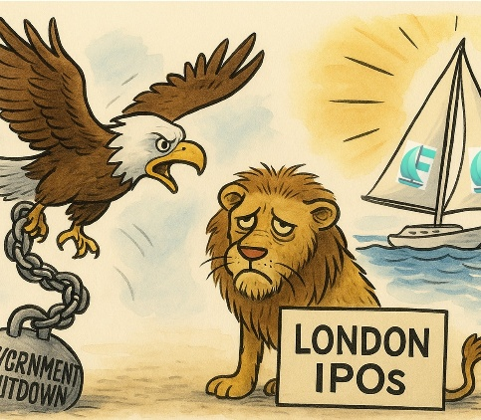

For more on how we're allocating across strategies at QuantQual – and what our investment partners are thinking – speak to your usual contact.

